**MINUTES OF THE REGULAR MEETING**

**OF THE CITY OF AUBURN PLAN COMMISSION**

**HELD ON OCTOBER 13, 2009**

The Plan Commission met for a regular meeting on Tuesday, October 13, 2009 at the hour of 6:00 p.m. The meeting was held at Auburn City Hall in the Council Chambers located at 210 E. Ninth Street, Auburn, Indiana.

All records from the October 13, 2009 meeting are on file in the Department of Building, Planning and Development office for review by the public.

**Call to Order / Roll Call**

The meeting was called to order at 6:10 p.m. by President Rick Ring.

President Rick Ring asked Zoning Administrator Vivian Likes toconduct the roll call.

*Present:* Steve Bruns; Mike Likens; Dick McKean; Don Myers; Richard Ring; Ellen Stahly; Barry Tilghman; Mike Watson; Al Wleklinski and DeKalb County Representative, Tim Griffin.

Members and Staff absent: Greg Kenner and Jerry Muzzillo.

Staff Present: Administrator, Bill Spohn; Zoning Administrator, Vivian Likes; and City Attorney, Erik Weber.

**Minutes**

Barry Tilghman moved to approve the regular minutes from the September 14, 2009 meeting. Al Wleklinski seconded the motion. The motion was carried unanimously by a vote of the commission.

**Old Business**

None.

President Rick Ring requested to change the order of the Plan Commission Agenda to move Other Business Item 1. PC-Dev Plan 2008-00000001-Starting Gate Powersports time extension request to the second item of New Business. The commissioners concurred.

**New Business**

1. **Public Hearing – Permit No.: PC-Prim Plat 2009-00000001 – PRJ – Bill Hohler.**

* Primary/Secondary Re-Plat of Lot #63Amended Plat of Bridgewater Section III.

Mr. Ring opened the public hearing.

Mrs. Likes stated that the applicant was requesting a continuation to resolve some property and development covenant and restrictions issues with this project.

Mr. Ring asked for a motion on the request.

Don Myers moved to continue the petition to the November Plan Commission meeting. Mike Watson seconded the motion. The motion was carried unanimously by a vote of the commission.

1. **PC-Dev Plan - 2008-00000001 - Starting Gate Powersports – Dev. Plan. (PC originally approved 05-13-2008)** - Request 1-year time extension for project.

Mr. Ring asked Mrs. Likes to present the request to the commission.

Mrs. Likes informed the commission that the expiration date for this petition was approaching November 13, 2009, and that the petitioner had been in contact with our department by email.

Starting Gate is requesting a one-year extension on the petition. Mrs. Likes stated that the petitioners request is due to the recent economic times and anticipates beginning the project spring 2010 and hopefully complete the project prior to next fall.

A brief discussion then ensued and it was noted that the petitioner could request an additional two extensions for a total of three years of extensions per state statute.

Ellen Stahly moved to approve the request for a one-year time extension. Al Wleklinski seconded the motion. The motion was carried unanimously by a vote of the commission.

Mr. Ring asked the audience to be sure to sign in at the back of the room on the sign in sheet.

1. **Public Hearing – Permit No.: PC-Zone 2009-00000003 – PRJ - ETJ Zoning Map - City of Auburn.** Zoning Map for the Extra-Territorial Jurisdictional (ETJ) areas.

Mr. Ring opened the public hearing and asked Zoning Administrator Vivian Likes to present the staff report.

Mrs. Likes informed the Commission that legal notice had been served in accordance with applicable statutes and ordinances in regards to this application.

Mrs. Likes presented the Staff Report and read several letters from property owners into the record.

**Summary:**

The City of Auburn will assign City of Auburn zoning classifications to the City of Auburn/DeKalb County Extra-Territorial Jurisdiction (ETJ) areas.

The Auburn zoning classifications are needed to be added to the City of Auburn Zoning Map in order to align the proper zoning classifications of the city in accordance to the Inter-Local Cooperation Agreement between DeKalb County and the City of Auburn as it relates to Planning, Zoning, Subdivision Control, Permitting and Enforcement jurisdictions. This agreement was approved on September 18, 2007, by the DeKalb County Commissioners and City of Auburn Common Council.

The Agreement enables the City Plan Commission to better plan for Auburn’s future growth and development by allowing local control of areas just outside the city’s boundaries to be part of the same planning and enforcement ordinances as those inside its jurisdiction. It closely follows the recommendation for the 2005 Future Growth Plan that was approved by the Auburn Plan Commission and City Council as per the 1987 Comprehensive Master Plan.

See references below:

***Part 2: Zoning***

**Section 2.1** The City shall have zoning jurisdiction over the unincorporated areas designated in Exhibit A, Extra-territorial Jurisdiction Map.

**Section 2.2** The City shall maintain a valid comprehensive plan that acknowledges the boundaries of the ETJ and designates future land uses consistent with the County’s comprehensive plan.

**Section 2.3** The City shall maintain a valid zoning ordinance that is complementary of the City’s comprehensive plan, especially the future land use plan.

The Extra-Territorial Jurisdiction (ETJ) areas were reviewed in conjunction with the adjacent city zoning and the Future Land Use Map; and the proposed zoning is in line with those zonings. The Extra-Territorial Jurisdiction (ETJ) areas are to ensure that these areas will eventually be a part of the city and are zoned according to the city’s zoning plans. Due to the nature of the boundaries of these areas, it is best to describe these zones by a zoning map rather than by deed descriptions.

**A. Plan Review/Routing comments:** *All City Departments:* Approved.

**B. Planning Staff Recommendation:**

The areas proposed for the zoning are compatible with the surrounding land uses and in conformance with our 1987 Comprehensive Master Plan and the 2005 Future Land Use Map and the amended Zoning Code Chapter 150 – Ordinance 2008-01.

Staff recommends that the request be forwarded to the Common Council with a favorable recommendation from Plan Commission to Zone the properties as described on the map as shown.

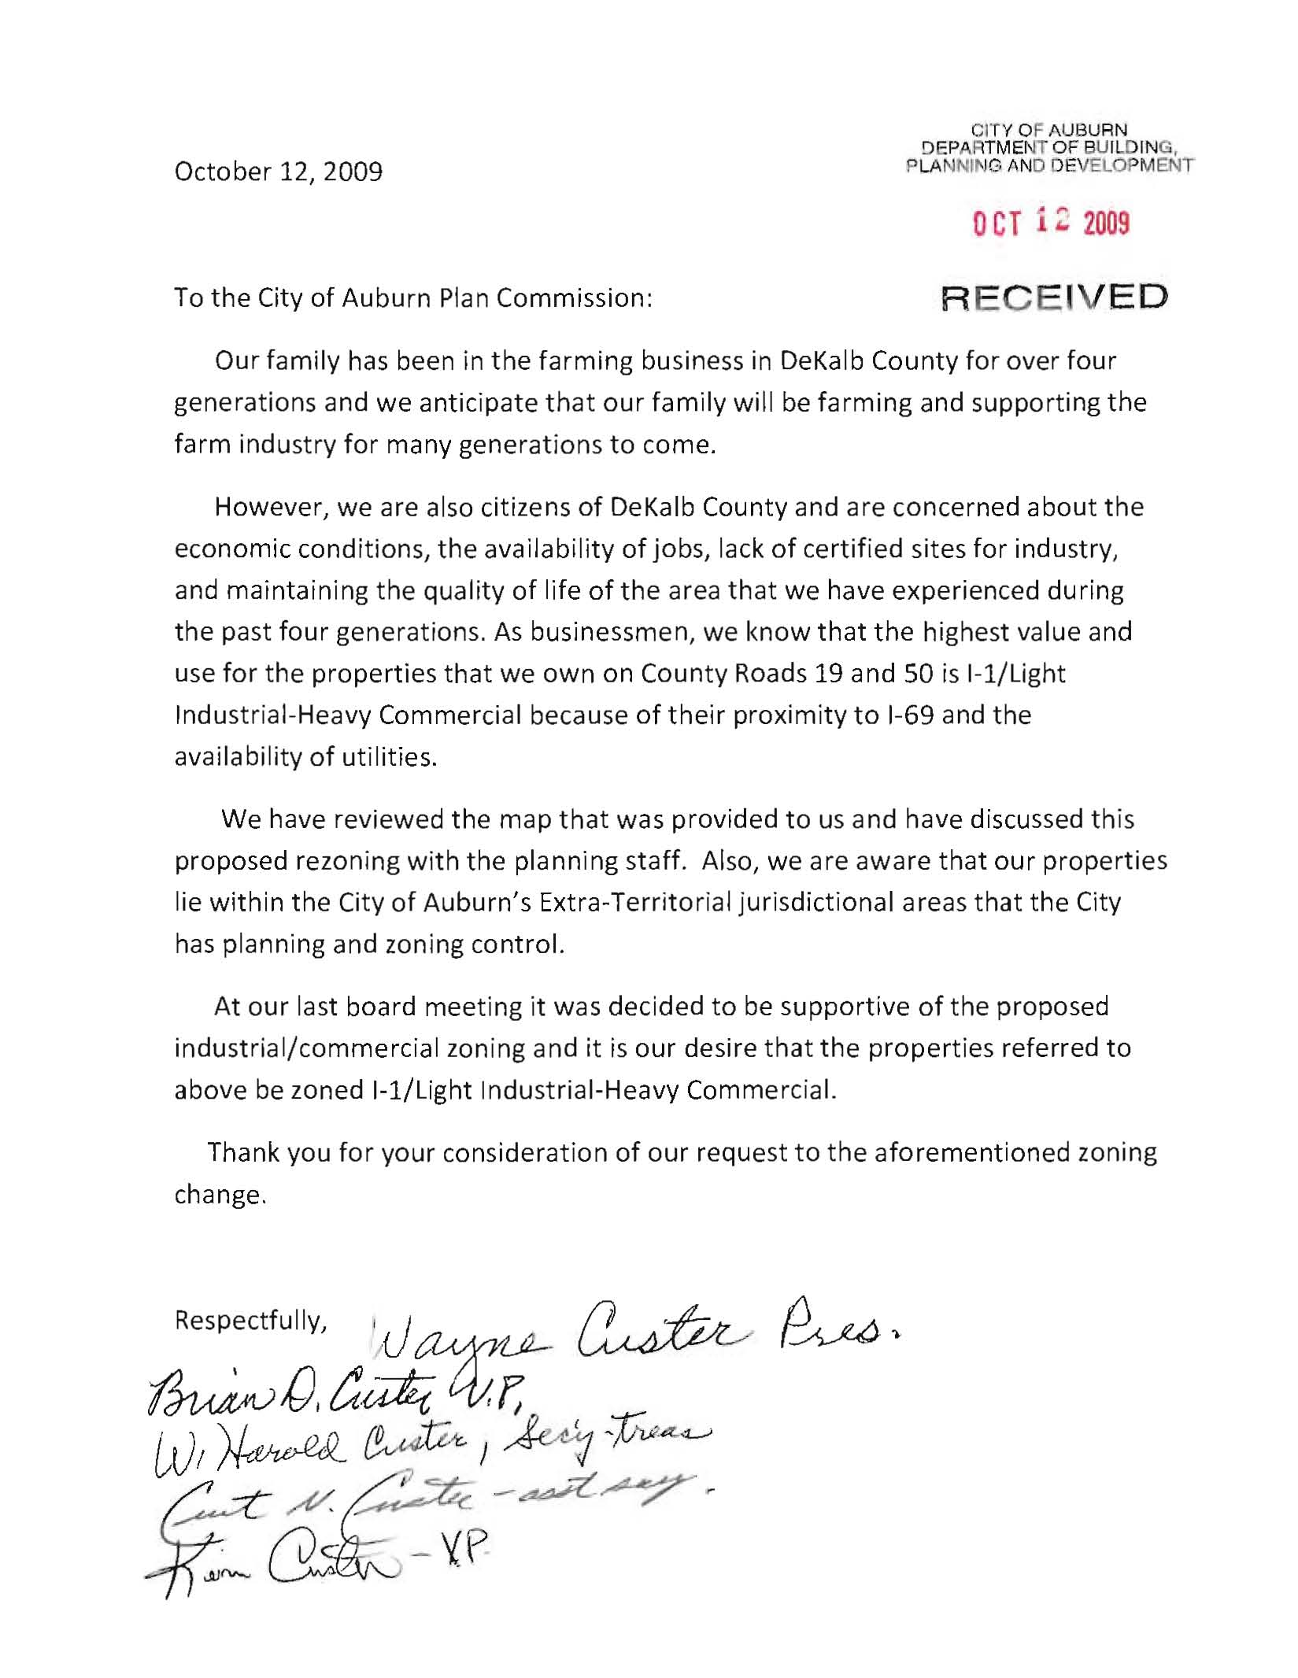

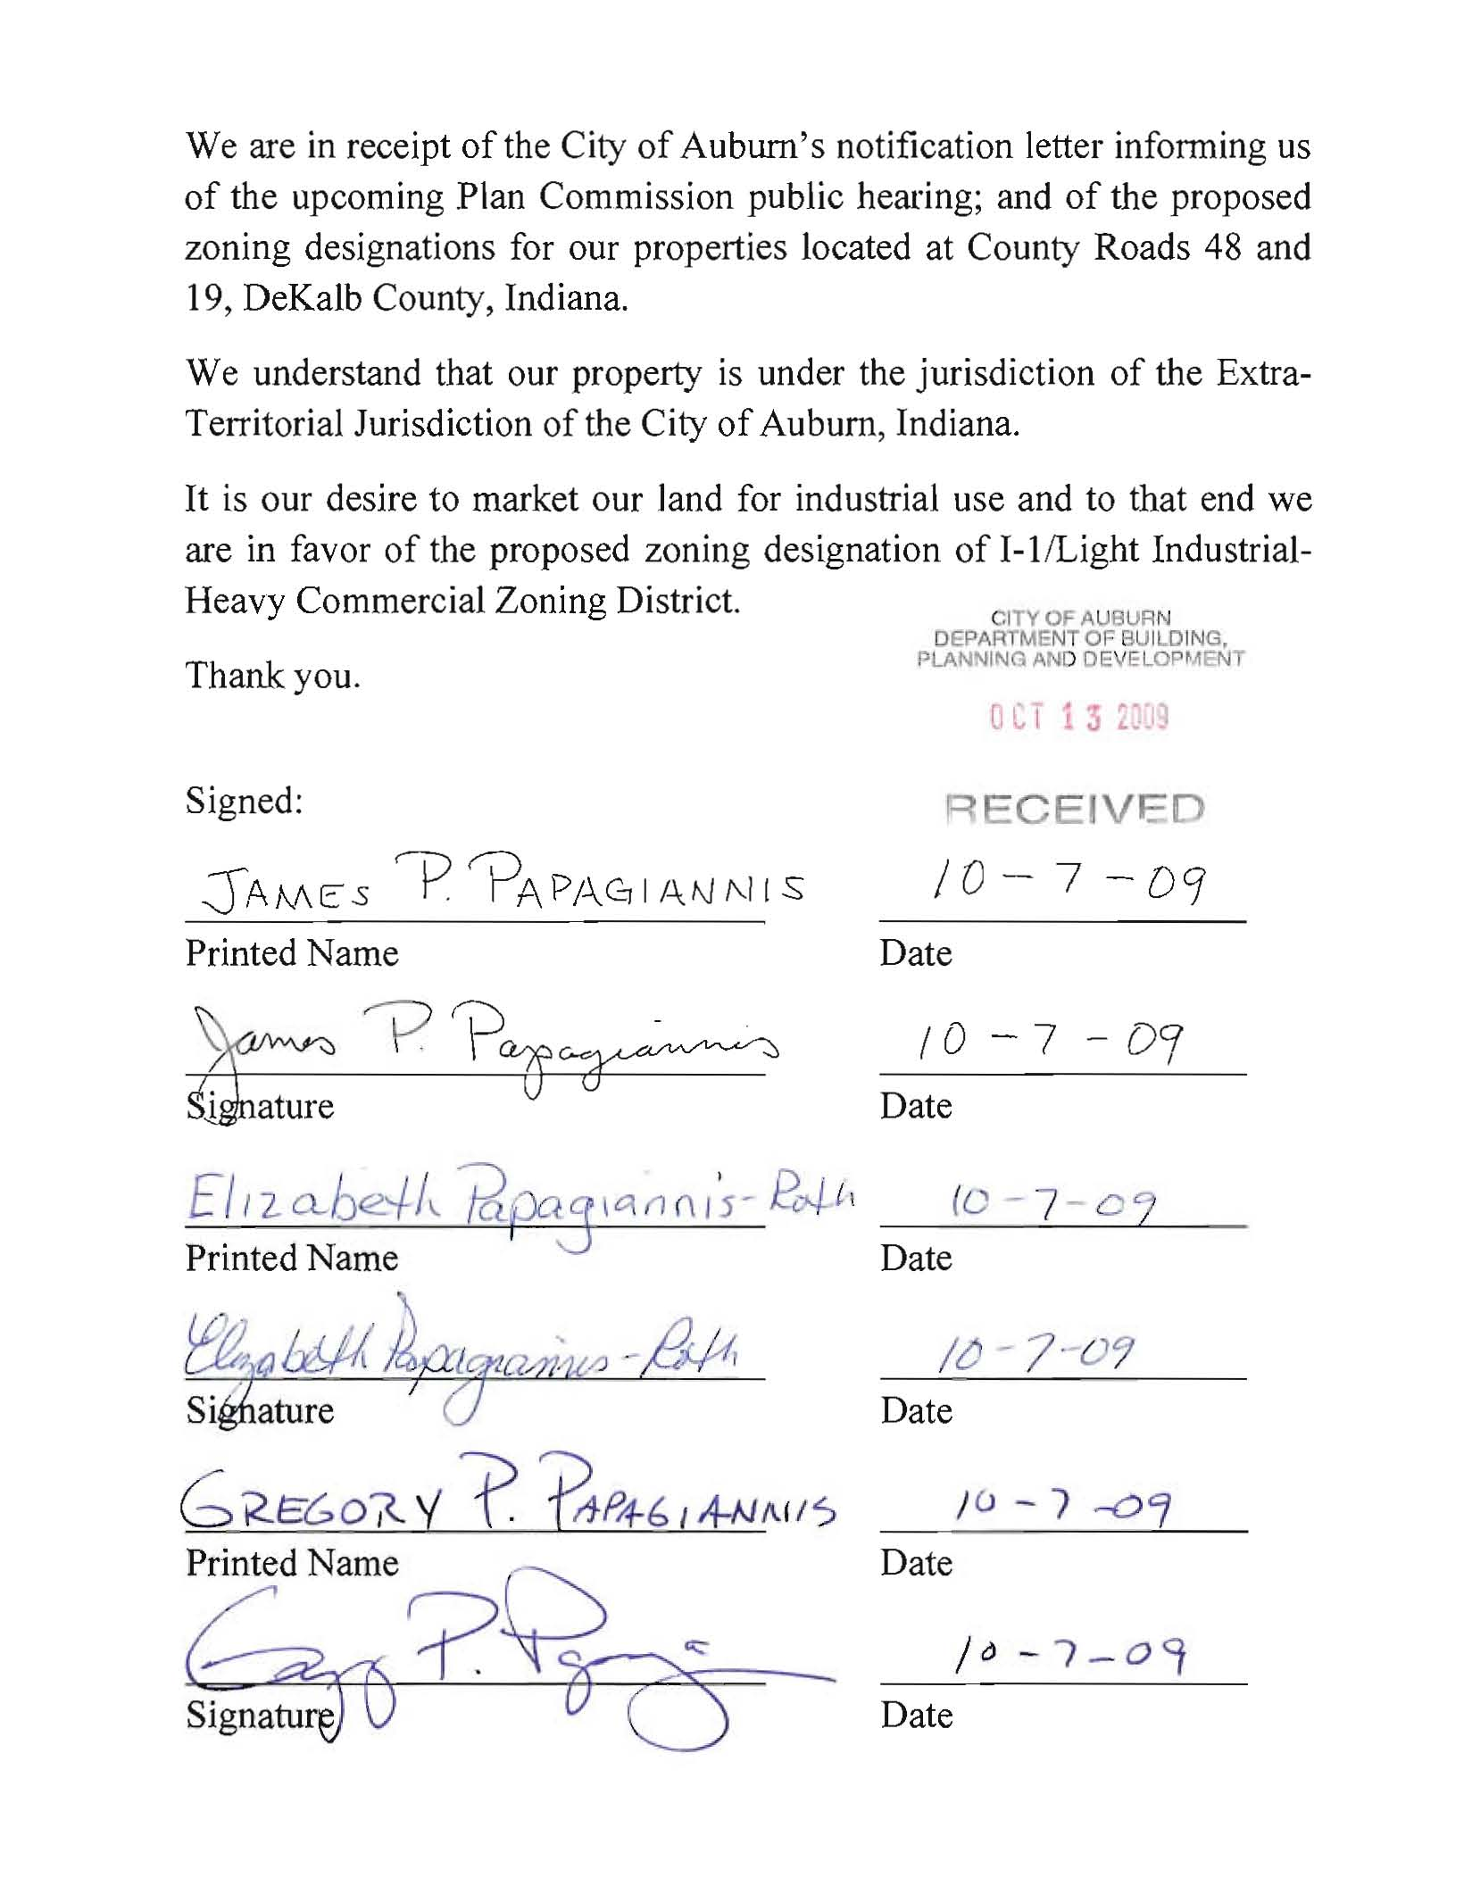

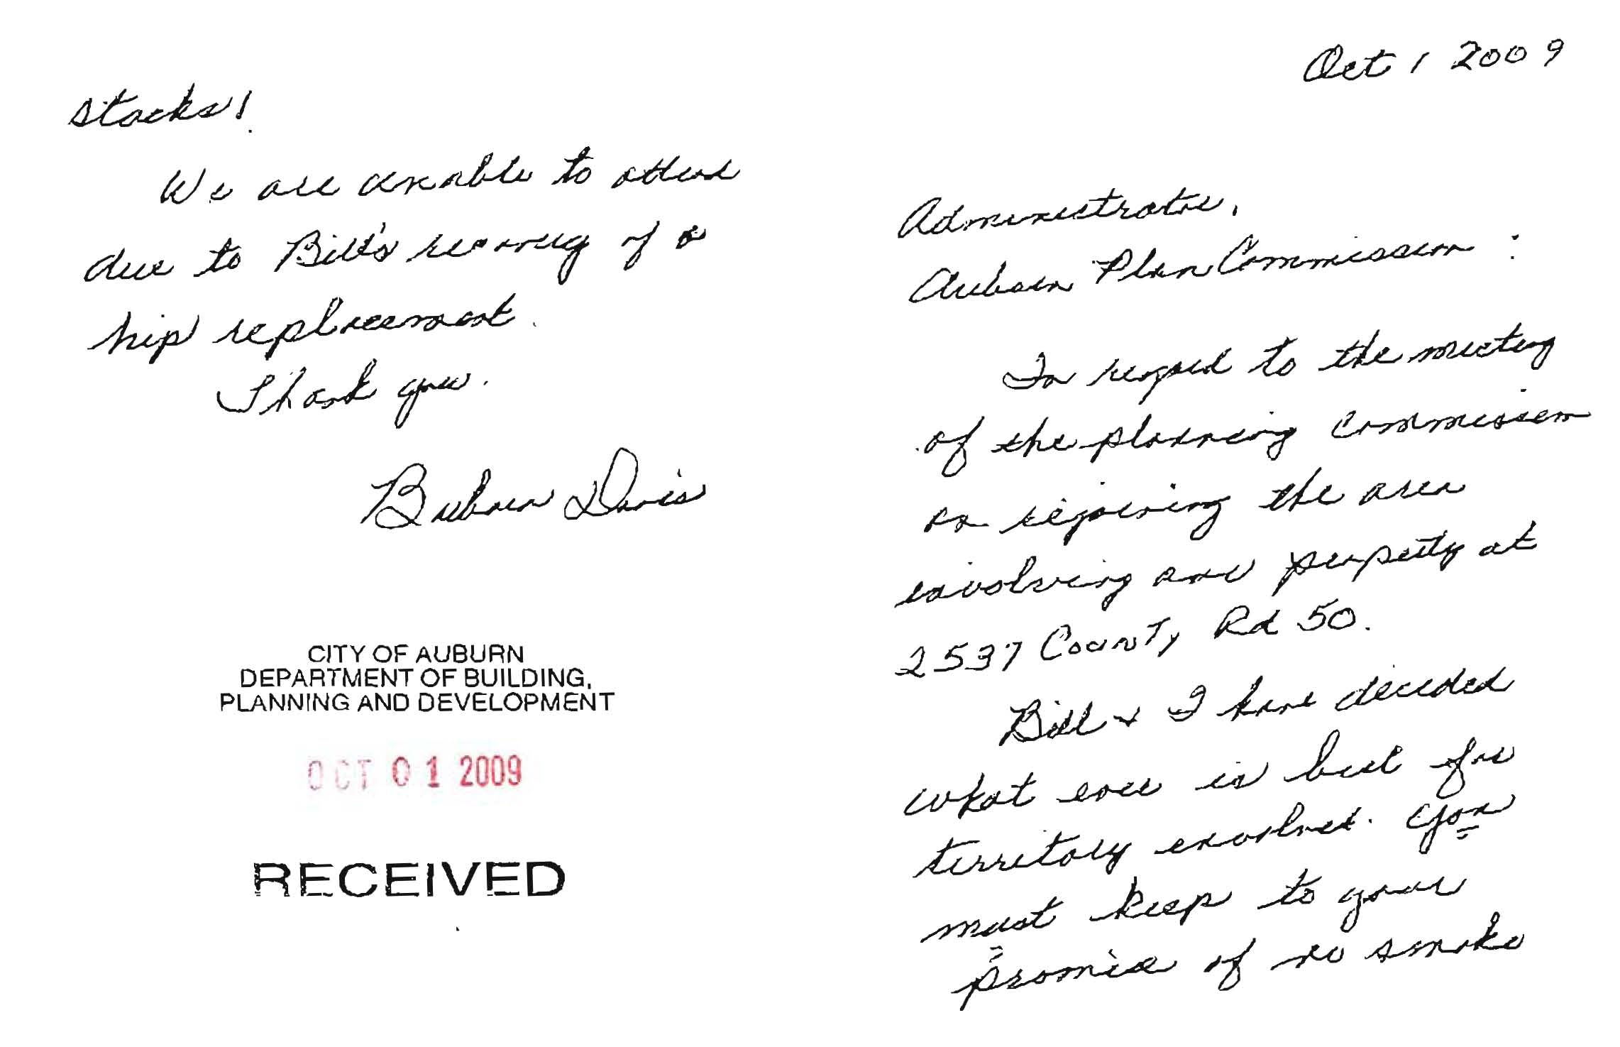

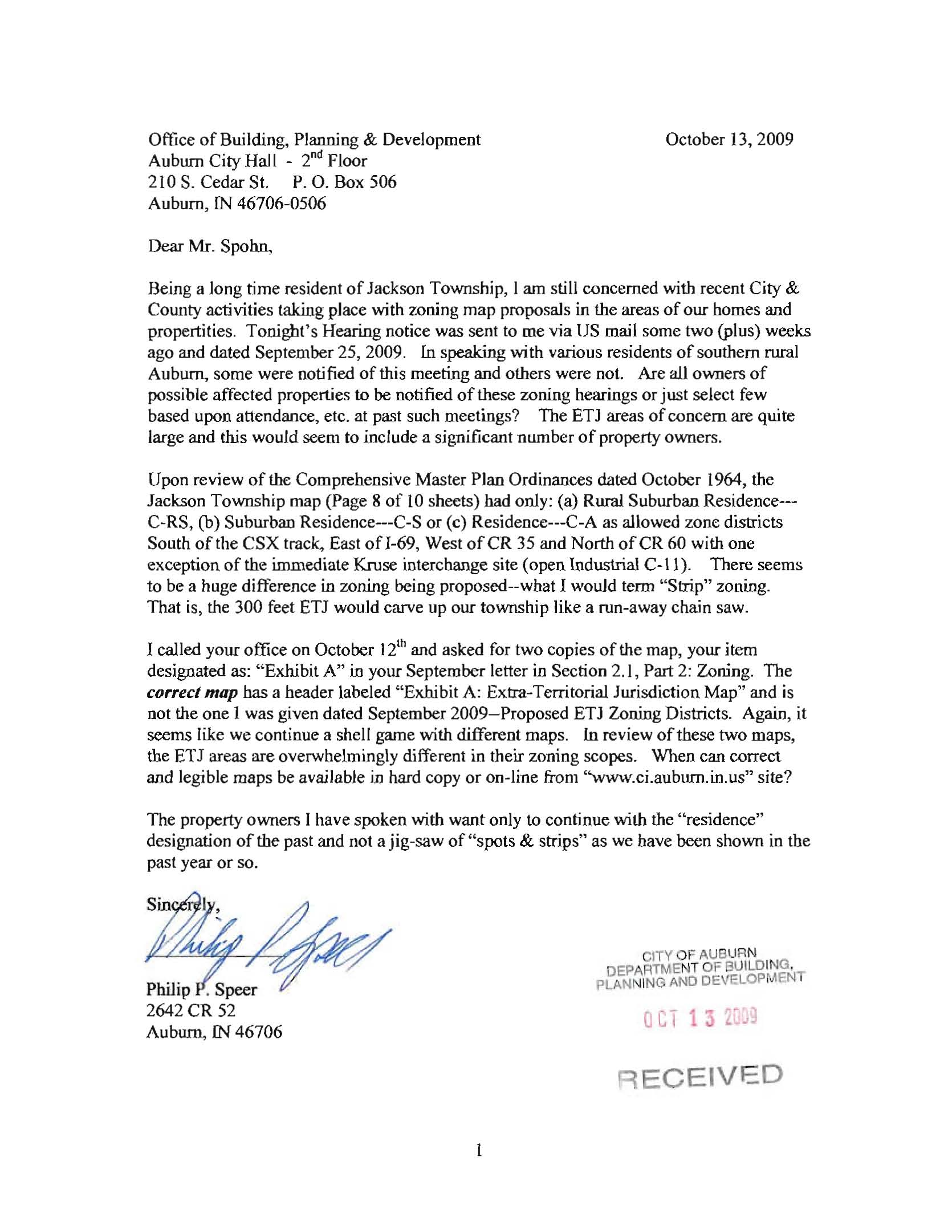

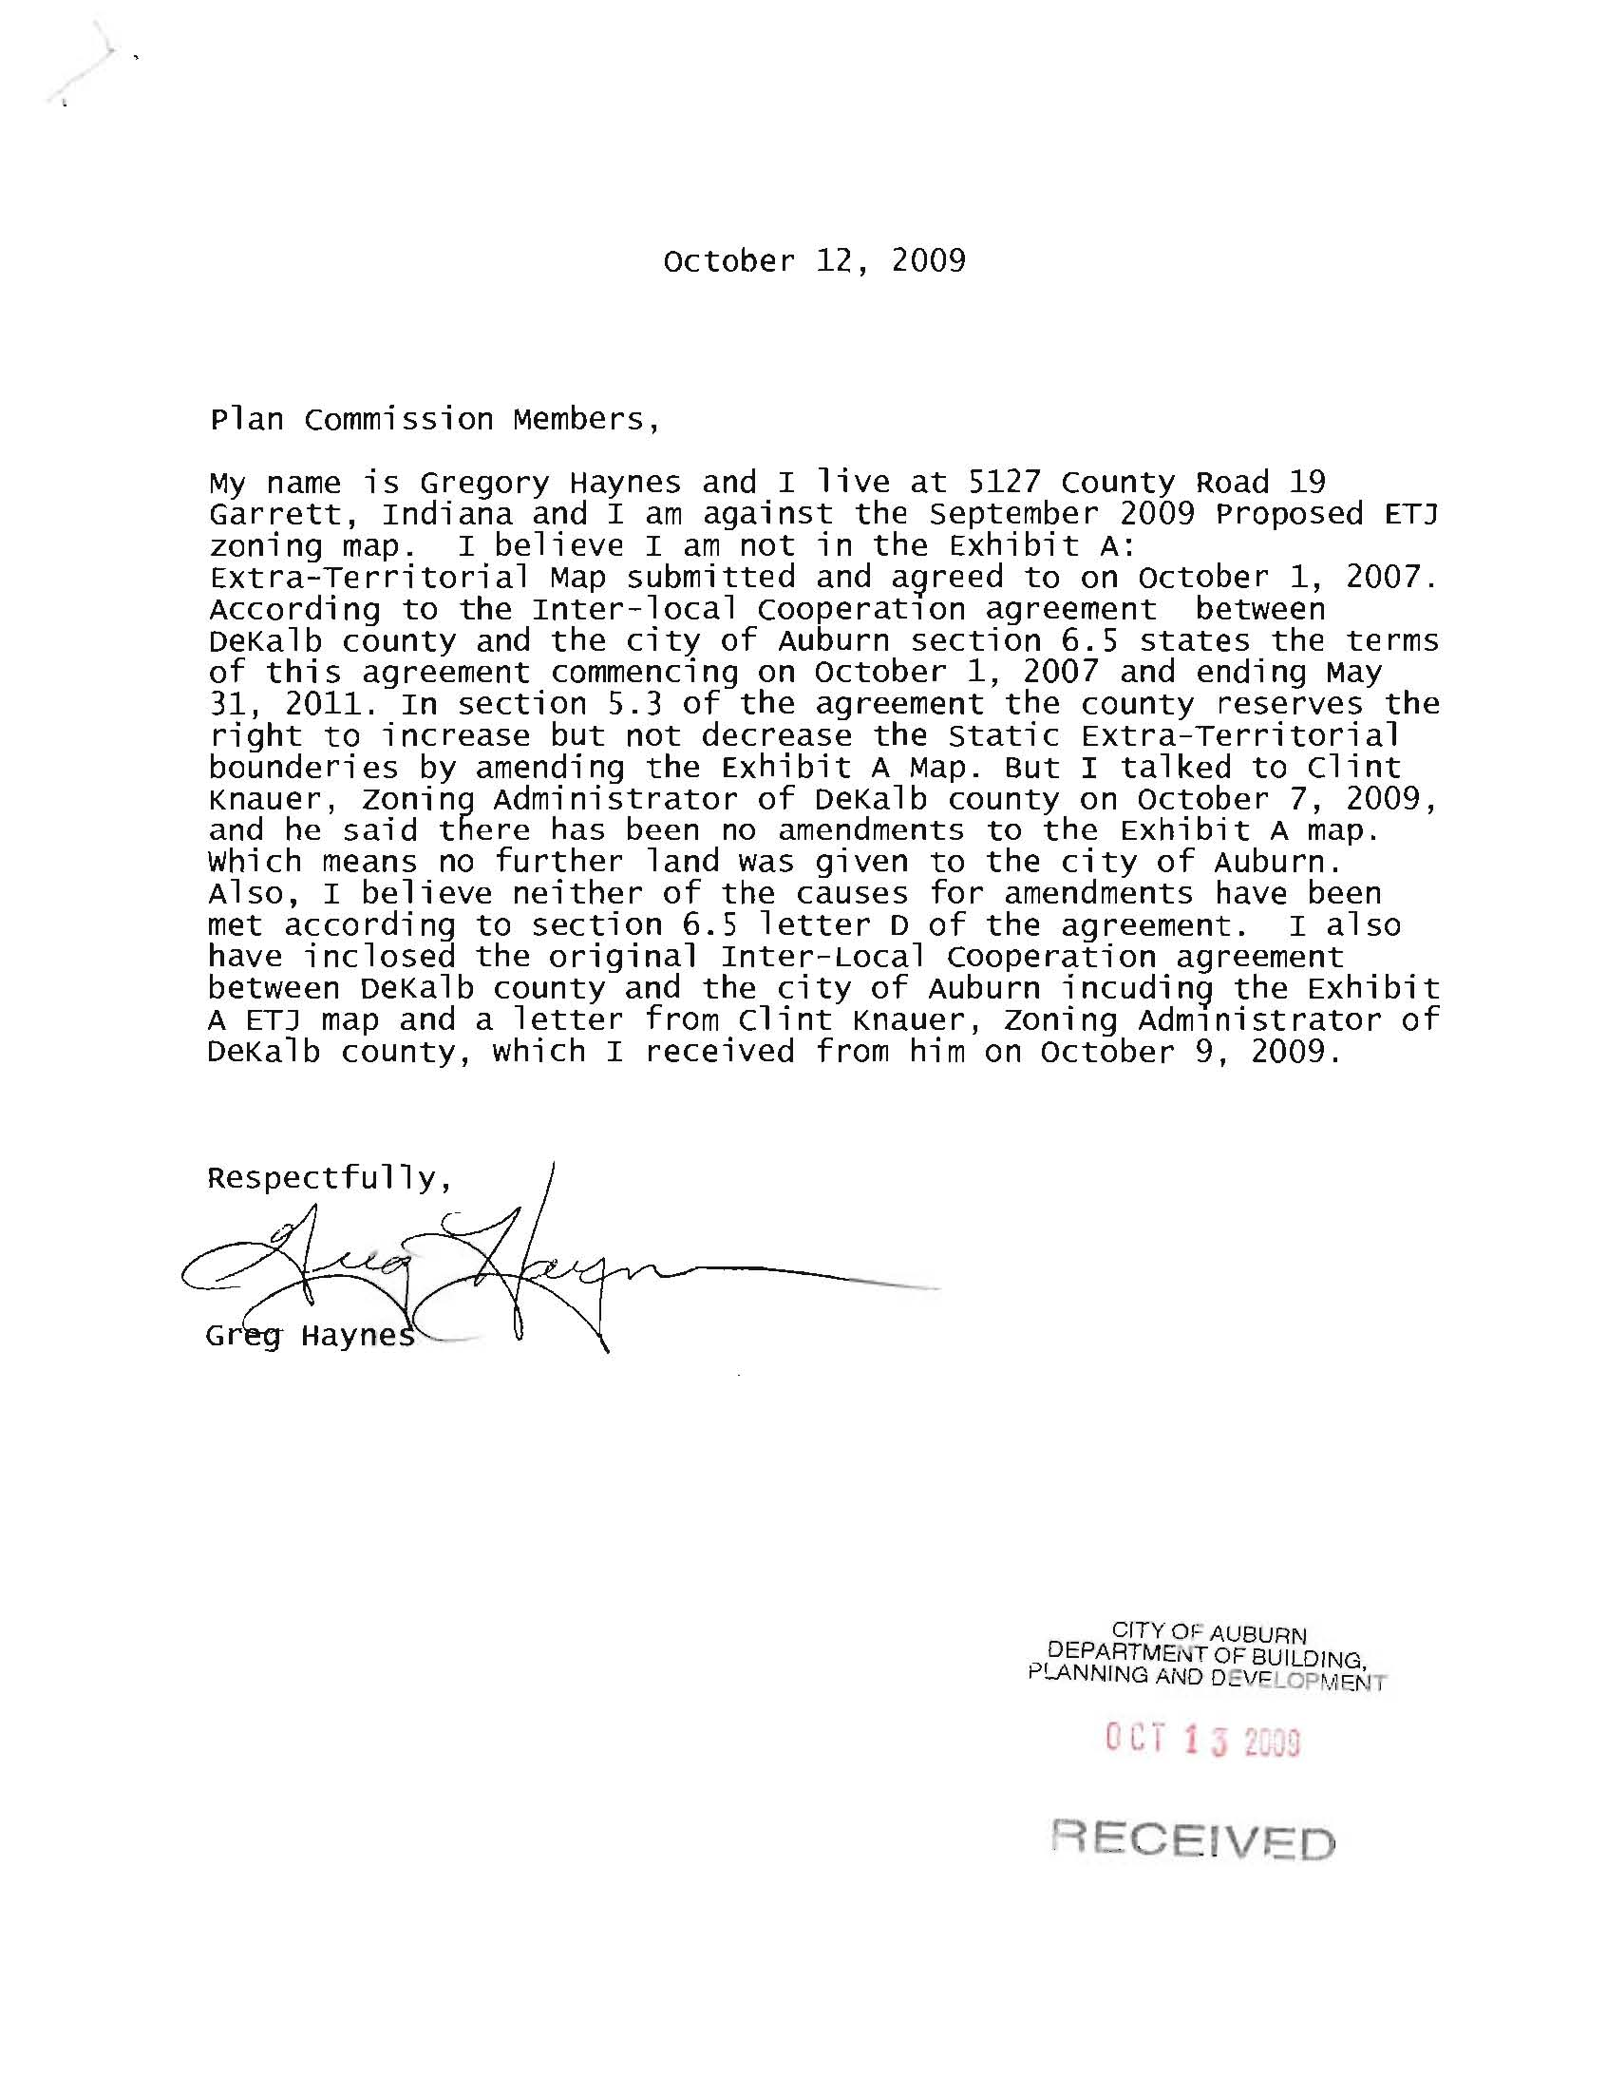

Attached to Mr. Haynes’ letter were an unrecorded copy of the Inter-Local Agreement and a copy of a letter from Mr. Clint Knauer, DeKalb County Zoning Administrator to Mr. Haynes dated October 9, 2009.

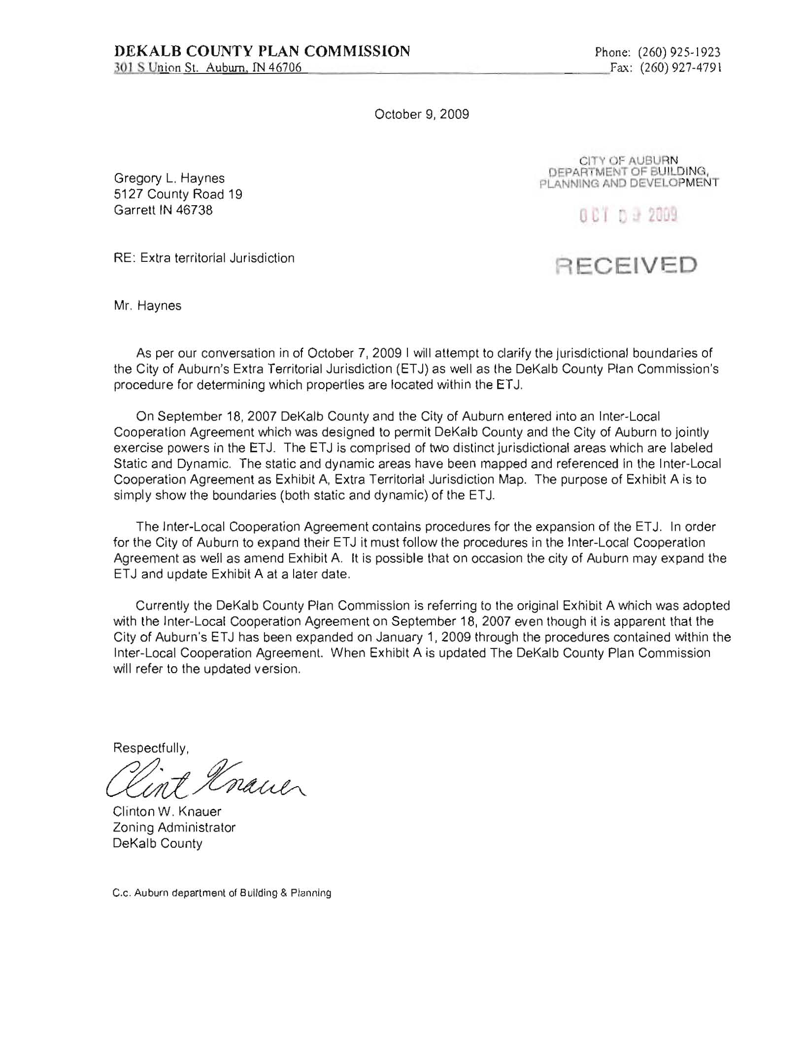

Mr. Ring asked the commissioners if there were any questions for Mrs. Likes from the staff report presentation. There were none.

Mrs. Likes then turned the floor over to Administrator, Bill Spohn, who stated that he had met with the DeKalb County Zoning Administrator and other county representatives and that the maps the city is using are correct.

Mr. Spohn gave a history of how the Inter-Local Agreement was developed and what areas the official City of Auburn Extra Territorial Jurisdiction (ETJ) actually contain and why those areas were included in the agreement. Mr. Spohn also stated that the city ETJ was expanded in January of 2009 to include Mr. Haynes’ property and several other properties.

Mr. Spohn explained that according to state statute the only legal notice must be in the newspaper and that letters did not need to be mailed to property owners. Mr. Spohn also explained that the department staff went above and beyond the requirement the first time the application was presented to the Plan Commission.

Mr. Spohn explained the city’s Future Land Use Map from 2005 to the commission and the audience and explained that the map is not a zoning map.

Mr. Spohn explained the changes to the proposed zoning map for the ETJ areas.

1. The addition of a buffer area around the residences located along County Road 19

between County Roads 48 and 52.

Mr. Spohn was asked if the owners of the smaller parcels of properties were agreeable to the proposed zoning. Mr. Spohn stated that Mayor Yoder met with the property owners of the smaller parcels and that we understood from those meetings that the proposed zoning was a compromise between their wishes and the wishes of the owners of the larger parcels in the area.

1. The areas between County Roads 23 and 427:

a. The west side of the area would be zoned I-1.

b. The east side of the area would be zoned R-1.

Mr. Spohn explained that the C-1 and C-2 designated zoning areas at the southeast of the area are existing zoning and that would be carried forward with the proposed zoning.

Mr. Spohn informed the commission that if the map presented at tonight’s meeting and were to become part of the city’s zoning ordinances, then DeKalb County would be receptive to rezoning the rest of the parcels involved to match the city’s zoning designation.

Mr. Spohn stated that for all other areas in the ETJ the proposed zoning was to remain the same as the previous proposed zoning designations.

Mr. Ring asked the commission if there were any questions for Mr. Spohn. There being none, Mr. Spohn gave up the floor.

Mr. Ring then opened up the floor to the public and explained the following rules:

1. Everyone would have an opportunity to speak.
2. There would be no repetition; the commission did not want to hear the same points from multiple individuals.
3. All comments and testimonies needed to address only the issue of the zoning of the extra territorial jurisdiction areas for the City of Auburn. All other issues would need to be addressed to the Mayor, City Council, and/or County Commissioners.
4. If the above rules were not adhered to, then the speaker would be asked to give up the floor and/or leave the meeting, depending on the situation.

Mr. Greg Haynes of 5127 Co Rd 19 took the floor to give further insight into his letter presented by Mrs. Likes. Mr. Haynes’ issues were more with whether his property should legally be included in the ETJ.

Mr. Ring informed Mr. Haynes that he would need to take his concerns to the Mayor, City Council, and the County Commissioners.

Mr. Spohn then explained that the Inter-Local Agreement is a living document and the areas the city has jurisdiction over are fluid and changing all of the time, such as with the water and sewer lines. Mr. Spohn explained that the map referred to as “Exhibit A” is just a reference point for the time that the document was approved by the county and city. Mr. Spohn explained that mapping in most cases is almost always behind the expansion allowed by a document.

Mr. Phil Speer of 4622 Co Rd 52 took the floor and stated that the maps must be improved due to the confusion that the maps are causing some individuals in regards to the zoning of their properties.

Mr. Ring asked Mr. Spohn to clarify the current zoning for the ETJ areas.

Mr. Spohn stated that staff is currently using the city’s equivalents to the county zoning that was in place at the time the Inter-Local Agreement took effect.

Mr. Ring explained that until a zoning ordinance is passed by the city for the ETJ there are no zoning maps for the ETJ areas.

Erica Shaffer of 5099 Co Rd 19 took the floor and asked if the woods in the buffer area would be left as buffer.

Mr. Spohn responded that the owner of the land with the woods had agreed to the proposed zoning of the land.

Mrs. Shaffer asked why there was an industrial zone for the strip of land between the two residential areas on the proposed map.

Mr. Spohn responded that the strip of land Mrs. Shaffer was referring to was for access to the land located behind her property.

Mr. Greg Rice of 2148 Co Rd 48 took the floor. Mr. Rice lives in an area to be zoned C-1 neighborhood commercial. Mr. Rice stated that he believed that most of the people in attendance of the meeting were opposed to the proposed zoning. Mr. Rice further stated that in a meeting between the owners of the smaller parcels, the Mayor had stated that there would be a 200 foot buffer. Mr. Rice stated that the buffer seemed to be changing.

Mayor Yoder stated that did not recall if he had told the property owners a definitive distance for the buffer area.

Chris Shaffer of 5099 Co Rd 19 took the floor. Mr. Shaffer stated that there was a wooded area to the north of the buffer area and he would like to see that woods included in the buffer area. Mr. Shaffer also stated that he thought the strip of land between the two buffered residential areas along Co Rd 19 didn’t make any sense to him and that he opposed the proposed zoning. The proposed zoning didn’t benefit the residents in the area and the residents can’t vote in the City of Auburn.

There was extensive discussion in regards to the issue of buffer areas and as to why the areas to the southwest of the city could not be left as residential until such time as a person or business wanted to use the area for industrial purposes. It was explained that the land, if left as residential may not be available in the future for industrial use. If left as residential more homes could be built in the area and not leave enough space for industrial use.

The reasoning for shovel ready land was explained by the staff and the commission in response to several audience members input. A shovel ready piece of land has in place electric, water, sewer, and fiber optics services and the soil samples and other info must already be known for the site to be considered by a site selector, which is also a site eliminator.

Jim Covell of 5145 Co Rd 427 took the floor. Mr. Covell pointed out some sites that he believed should be used first for industrial uses before the southwest side of the ETJ be used for industrial purposes.

President Rick Ring called for a short break at 7:28 PM.

President Ring reconvened the public hearing at 7:41 PM.

Diane Manon of 3201 Co Rd 40, daughter of Barbara Davis, took the floor. Mrs. Manon stated that she would like to see the map previously rejected by the City Council resubmitted to the council.

Mayor Norman Yoder took the floor and thanked the Plan Commission for the hard work they have put into the zoning process for the ETJ. Mayor Yoder also thanked Tammy Williams and Phil Speer for letting him use their homes to meet with the residents and property owners in the southwest section of the ETJ.

Mayor Yoder reiterated that having the area zoned as residential would negate the future use of the land for an industrial use and the requirements needed for a shovel ready site. Mayor Yoder stated that all previous maps needed to be put aside and the map before the room needed to be accepted as the only map of the moment. Mayor Yoder also stated that the current administration had to deal with a lack of foresight on the part of past administrations and that he did not want to leave future administrations with the same problems.

There being no questions for the Mayor, he gave up the floor.

Galen Eberhart, DeKalb County Economic Director took the floor. Mr. Eberhart reinforced the information that the Mayor provided and explained that his position is not like an obstetric doctor’s position. Mr. Eberhart stated that he does not usually have months to prepare for a site selector (eliminator). Mr. Eberhart only has a few days at best, sometimes only a few hours to respond to an inquiry regarding our county’s offerings for future businesses.

There being no questions for Mr. Eberhart, he gave up the floor.

Michael Walter of 320 W 17th St. took the floor. Mr. Walter stated that he was lodging a formal complaint with the commission regarding the restriction of audience members only being able to address the zoning of the ETJ and nothing more.

Mr. Walter then gave up the floor.

Jeanine Kleber of 2610 Co Rd 50 again took the floor and asked why a section of land surrounded by the southwest section of the ETJ was not included in the ETJ.

Mr. Spohn gave an explanation as to how the areas in the ETJ were chosen.

Mr. Ring stated that there had been a lot of thought and planning put into the ETJ. Mr. Ring stated that it is not perfect, but it is the best that the city has to deal with at this time.

The reasoning for shovel ready land was again discussed due to several audience members still having questions regarding the issue.

There being no one else in the audience wishing to speak, Mr. Ring closed the public hearing.

Mr. Ring then opened the public meeting portion of the petition by asking for discussion and questions from the commission.

After an in-depth discussion that concluded that the commission has had an unusual amount of time to deliberate the issues and heard from an array of many sources; and that the commission must decide what was best for the community as a whole, especially in light of the recession the area experienced.

Mr. Ring then asked city attorney Erik Weber to read the findings.

### *FINDINGS OF FACT:*

1. Legal notice for this application has been published in accordance with the applicable Indiana Code and City of Auburn local regulations.

* **Yes. The legal notice was published in The Star newspaper on October 1, 2009. In addition, previous identified property owners and interested parties were contacted as requested at earlier public meetings.**

2. The Extra-Territorial Jurisdiction (ETJ) zoning map is consistent with the Comprehensive Plan of the City of Auburn.

* **Yes. The areas proposed for the Extra-Territorial Jurisdiction (ETJ**) **zoning classifications are compatible with the surrounding land uses and in conformance with our 1987 Comprehensive Master Plan and the 2005 Future Land Use Map; and the amended Zoning Code Chapter 150 – Ordinance 2008-01.**
* **Also is compatible with the 2009 DeKalb County Zoning and Unified Development Ordinance as well as the Inter-Local Cooperation Agreement between DeKalb County and the City of Auburn execution dated September 18, 2007 as recorded at the DeKalb County Recorder’s office October 10, 2007.**

3. The Extra-Territorial Jurisdiction (ETJ) zoning map is consistent with current conditions and the character of current structures and uses of the areas.

* **Yes. The surrounding areas consist of: single-family residential uses, residential subdivisions, commercial and industrial areas, agricultural areas, and cultural facilities.**

4. The City of Auburn has satisfied all standards and conditions prescribed for approval under the City of Auburn Zoning Code and Subdivision Control of Ordinances.

* **Yes. The Extra-Territorial Jurisdiction (ETJ) zoning map is needed in order to align the proper zoning classifications of the City of Auburn in accordance to the Inter-Local Cooperation Agreement between DeKalb County and the City of Auburn.**

5. The Extra-Territorial Jurisdiction (ETJ) zoning map proposal is consistent with other uses in the

Extra-Territorial Jurisdiction (ETJ) areas, provides for coordination with existing and proposed developments and will not be injurious to the public’s health, safety and morals

* **Yes. The** **Extra-Territorial Jurisdiction (ETJ)** **zoning classifications of the City of Auburn in accordance to the Inter-Local Cooperation Agreement between DeKalb County and the City of Auburn will not be injurious to the public’s health, safety and morals. The intent is to provide a consistency of the land uses and zoning classifications of the Extra-Territorial Jurisdiction (ETJ) areas along with the surrounding areas.**

**ACTION OF THE COMMISSION.**

***MOTION TO:*  Approve and Forward a Favorable Recommendation to Common Council from the Auburn Plan Commission to assign zoning classifications as described on the Extra-Territorial Jurisdiction (ETJ) zoning map as shown and provided by the Planning Staff was put forth based on the above findings by Don Myers and seconded by Barry Tilghman. The motion was carried unanimously by the commission.**

**Vote:**

Member(s) Yes No Abstain Absent

Steve Bruns X ____ ____ ____

Greg Kenner ___ ____ ____ _X_

Mike Likens X ____ ____ ____

Dick McKean X ____ ____ ____

Jerry Muzzillo ___ ____ ____ _X_

Don Myers X ____ ____ ____

Rick Ring X ____ ____ ____

Ellen Stahly X ____ ____ ____

Barry Tilghman X ____ ____ ____

Mike Watson X ____ ____ ____

Al Wleklinski X ____ ____ ____

1. **Public Meeting – Permit No.: PC-Other 2009-00000001 – PRJ – PC Rules and Procedures.**

- Continued - City of Auburn Planning - Rules and Procedures – Draft version.

It was decided that due to the lateness of the hour to table the review of Draft C of the Plan Commission Rules and Procedures.

**MOTION TO: Table Permit No.:** PC-Other 2009-00000001 Plan Commission Rules and Procedures **was put forth by Al Wleklinski. Barry Tilghman seconded the motion and it was carried unanimously by a vote of the Commission.**

**Other Business**

1. Address Report – None.

**Reports, Communications, Correspondence**

1. President, Rick Ring:

Mr. Ring informed the commission that member Greg Kenner had resigned at the last City Council meeting due to a move to LaGrange County. Mr. Kenner’s resignation was supposed to take effect at the end of October 2009. Mr. Ring stated that he was disappointed Mr. Kenner had not attended the October Plan Commission meeting. Mr. Ring stated that he had hoped to be able to thank Mr. Kenner for his service to the City Council and the Plan Commission and asked the staff to convey plan commissions thanks to Mr. Kenner. Mr. Ring stated that there was no information as to whom Mr. Kenner’s replacement from the City Council would be.

1. County Liaison to the City – Tim Griffin:

Mr. Griffin stated that he believed the city plan commission had gone in the right direction with the zoning decided on for the extra territorial jurisdiction.

1. City Liaison to the County – Don Myers:

Mr. Myers stated that things were going well with the county plan commission and he was enjoying the amount of participation that he was being allowed.

1. City Attorney, Erik Weber – None.
2. Department Administrator, Bill Spohn – None.
3. Zoning Administrator, Vivian Likes – None.

**Upcoming Scheduled Meeting Dates**

### Plan Commission: November 10, 2009 at 6:00 p.m.

* 1. Board of Zoning Appeals: October 27, 2009 at 6:00 p.m.
  2. Board of Public Works and Safety: October 22 & November 12, 2009 at 9:00 a.m.
  3. City Council: October 20 & November 3, 2009 at 6:00 p.m.

**Adjournment**

There being no further business to come before the commission, a motion to adjourn the October 13, 2009 Plan Commission meeting was made by Mike Watson and seconded by Barry Tilghman. The motion carried unanimously. The meeting adjourned at 8:31 PM.

_____________________________

Secretary: Al Wleklinski

Michelle Lassiter, Department of Building, Planning and Development prepared the minutes.